2021 SOAPS Invitational
Water Quality


Science Olympiad at Penn State Invitational

Team Name:______________________________________________________________
Participant Names:______________________________________________________

Total Score:_____/150 Rank:______

Test Questions (ANSWER KEY):
Part I: Marine and Estuary Ecology
Use the survival curve provided below to answer question 1.
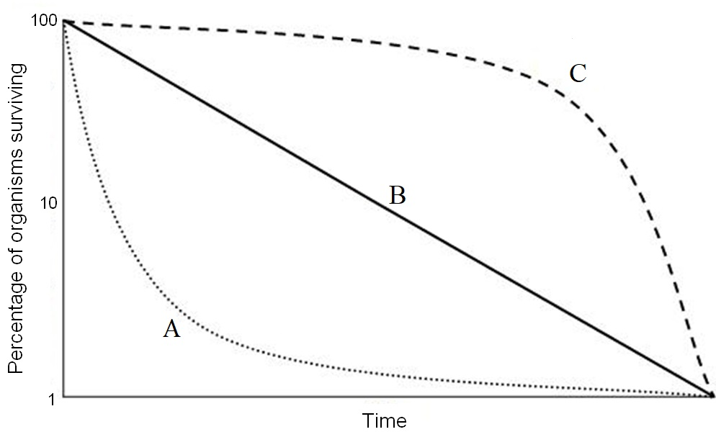
- Match the following species to the respective survival curve that best describes them. Choices A, B, and C may be used more than once or not at all. (4 points)
  - Microalgae ____A_____ (r)
  - Cichlids ____C_____ (k)
  - Blue whale _____C____ (k)
  - Salmon ____A_____ (r)

- In selection theory, species that follow r-selection have offspring that develop _________ independence and species that follow k-selection have offspring with a _________ability to learn. (1 point)
  - early, low
  - late, low
  - early, moderate
  - late, moderate
  - early, high
  - late, high

- In August and October of 2020, a harmful algal bloom occurred in Lake Erie, but it was less severe than the previous HAB that occurred in 2019. Which of the following do scientists say may have contributed to the lower severity of the HAB in 2020? (1 point)
- High winds in September
- Decreased rainfall in the spring
- Lower TBP levels in the Maumee River
- Both b and c are correct
- a, b, and c are all correct
- None of the above

- Water from the ocean that evaporates during the water cycle has a large effect on the Earth’s climate. This water vapor is responsible for raising the temperature of greenhouse warming by ____23℃______. Please provide your answer in degrees Celsius. (1 point)

- Where is the largest dead zone in the United States located? (1 point)
Gulf of Mexico

- Which of the following cycles is the slowest at cycling nutrients? (1 point)
  - Carbon
  - Nitrogen
  - Sulfur
  - Phosphorus
  - a and d take about the same amount of time to complete a cycle
  - c and d take about the same amount of time to complete a cycle

Use the figure below to answer question 7.
- Label each step of the water cycle. (12 points)
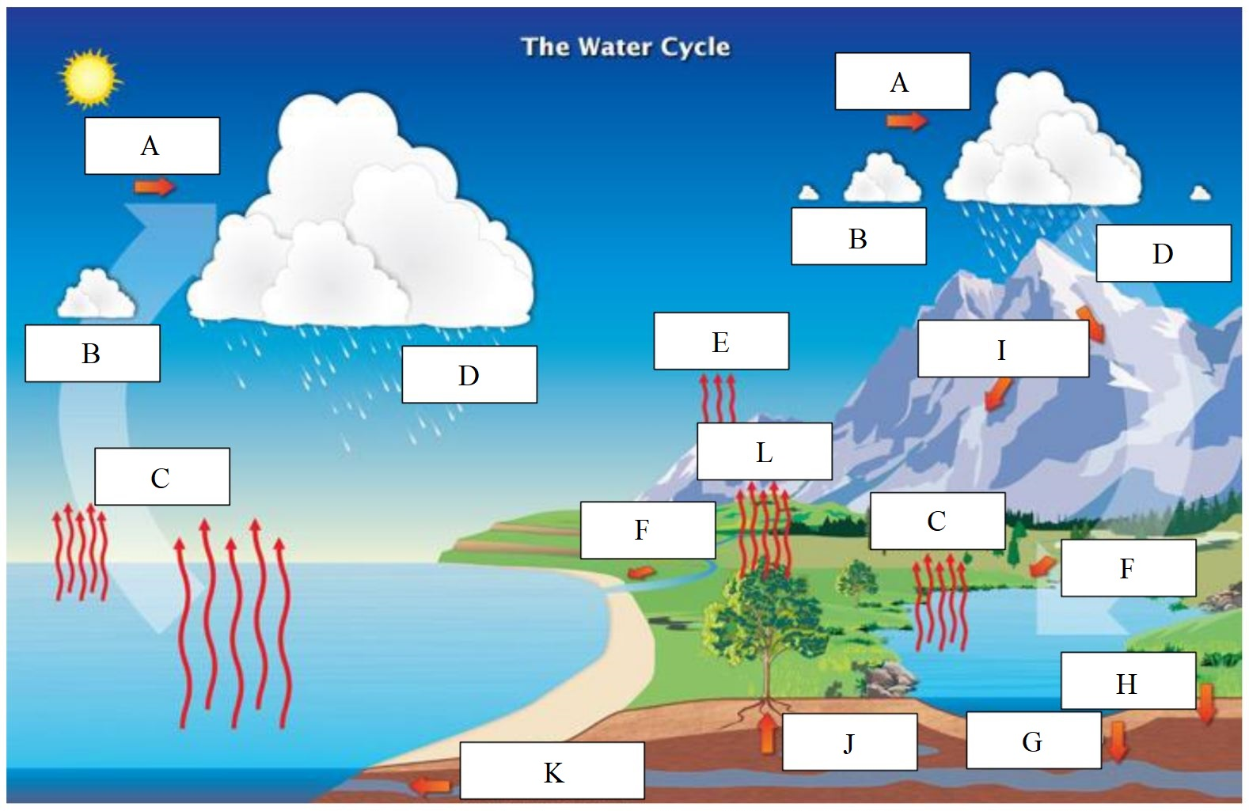
- Transportation g. Percolation
- Condensation h. Infiltration
- Evaporation i. Snow melt runoff
- Precipitation j. Plant uptake
- Sublimation k. Groundwater flow
- Surface flow l. Transpiration

- In the water cycle where does water have the longest residence time among the locations listed below? (1 point)
  - Oceans
  - Swamps
  - Atmospheric
  - Rivers
  - Biospheric

- What is the process in the Nitrogen cycle called where atmospheric nitrogen is converted to a biologically utilizable form? Provide an example of a species that would be responsible for this step in an estuary. (2 points)
Nitrogen fixation (1 point)
Any of the following: Cyanobacteria, heterotrophic bacteria, autotrophic bacteria, aquatic plants, green algae (1 point)

- Which of the following statements about coagulation is correct? (1 point)
  - Metallic salts are often used as coagulants
  - The negative charges of particles are neutralized
  - Coagulants can only be inorganic substances
  - All of the above are correct
  - a and b are correct
  - None of the above

- Which of the following statements about flocculation is correct? (1 point)
  - In potable water treatment flocculation is the step before coagulation
  - Flocculants can be in solid or liquid forms, but not emulsion forms
  - Cationic polymer emulsions are not used as flocculants because they are ineffective at forming large clumps of suspended particles
  - a and c are correct
  - b and c are correct
  - None of the above

- Energy moving through a food chain: (1 point)
  - Is able to be recycled
  - Is lost by about 90% between trophic levels
  - Influences the number of organisms in successive trophic levels
  - a and c are correct
  - b and c are correct
  - None of the above

Use the following simple food chain to answer question 13:
Phytoplankton → Zooplankton → Planktivores → Piscivores

- If overfishing occurs which type(s) of species will increase in abundance? (1 point)
Planktivores and Phytoplankton

- If a food web becomes top-heavy what effect will this have on the organisms at the top of the food web? (1 point)
  - They can become growth-stunted
  - They will start to consume organisms further down in the food not consumed previously
  - They can completely die out
  - All of the above
  - a and c are correct
  - b and c are correct

- What type of interaction occurs when one group of organisms indirectly affects another group by feeding on animals that eat them? (1 point)
Cascade interaction

- What condition is common in salt marshes and explain why. (2 points) Tie Breaker #4
Hypoxia (1 point)
Salt marshes are frequently submerged by the tides and contain a lot of decomposing plant material, which will decrease the oxygen concentration. (1 point)

- Which of the following statements about salt marshes is true? (1 point)
  - They protect shorelines from erosion
  - They reduce flooding and filter runoff
  - Salt marshes occur more frequently in mid to high latitudes
  - The United States has experienced a tremendous loss of salt marshes
  - All of the above
  - None of the above

- Which of the following statements about mangroves is correct? (1 point)
  - They are found between the latitudes 40° and -40°
  - Indonesia has the largest amount of mangrove coverage
  - Mangroves grow in areas with high oxygen content in the water
  - Mangroves flood seasonally
  - All of the above
  - None of the above

- Explain the difference between a grazing food web and a detrital food web? (2 points)
A grazing food web has plants or other photosynthetic organisms at its base, while a detrital food web consists of a base of organisms that feed on decaying organic matter, called decomposers or detritivores. (1 point for each type of food chain that is correctly described)

- Which of the following are true for estuaries? (1 point)
  - Provides a resting stop for migratory birds during long journeys
  - Provides many jobs and are a large source of income
  - Filters pesticides out of water while allowing heavy metals to pass
  - Dissipates storm surges
  - All of the above
  - a, b, and d are correct

- What is the nickname that has been given to estuaries? (1 point)
“Nurseries of the sea”

- Explain why coral is capable of two different types of succession? Make sure to clearly identify what these types are. (3 points)
Coral is capable of both primary and secondary succession. (1 point for each type of succession identified.)
Coral can be the first species to colonize an area, for example, after lava created an area with no plant life, which is characteristic of primary succession. Coral can also continue to spawn new offspring on top of itself in the creation of coral reefs in a previously disturbed area, taking place in secondary succession. (1 point for explanation. Must mention both types of succession and no partial credit for the explanation will be given.)

- Coral displays what type of selection strategy? Explain why it is categorized as such. (2 points)
R - strategy (1 point)
Coral is an r - strategy species because it is a colony of polyps that releases millions of young at a time. Little resources are devoted to the offspring. (1 point for explanation)

- Which of the following statements is correct about marine debris? (1 point)
  - They can transport species to their non-native areas
  - Most marine debris collect in the epipelagic zone
  - Marine debris cannot make it deep enough to reach the hadalpelagic zone
  - Marine debris can travel through a food chain
  - a and d are correct
  - b and c are correct

- Which of the following statements about sedimentation pollution is correct? (1 point)
  - The sediment delivery ratio can be greater than 1.0
  - The sediment enrichment ratio can indicate the economic cost of chemical loss
  - In surface erosion the sediment transported has a finer texture than the source soil
  - Sedimentation pollution has both physical and chemical dimensions
  - a and c are correct
  - b, c, and d are correct

- In a fluctuating environment food webs are usually __________, and in environments where conditions are stable food webs tend to be ___________. (1 point)
  - long; short
  - short; long
  - less stable; more stable
  - detrital; grazing
  - detrital; microbial
  - microbial; detrital

- What is Pennsylvania's largest surface water pollutant by volume? (1 point)
Sediment/Sedimentation pollution

- The San Francisco Bay is an example of what type of estuary? (1 point) Tie Breaker #1
Tectonic estuary

- Name two of the four common chemicals found in sunscreen that can lead to coral bleaching and coral death in low concentrations. (2 points)
Oxybenzone (Benzophenone-3, BP-3)
Butylparaben
Octinoxate (Ethylhexyl methoxycinnamate)
4-methylbenzylidene camphor (4MBC)
(1 point for each correct answer. Names in parentheses are also accepted.)
Part II: Coral Reef Macroflora and Fauna Identification
Use the following for questions 30-34:
A:
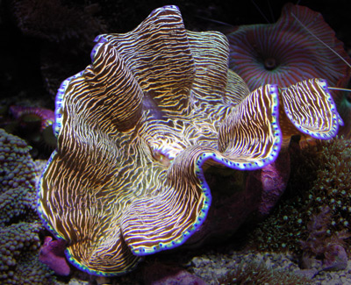

- What is the common name of organism A? (1 point)
Giant Clam

- In which of the following colors are members of organism A found throughout the world? (mark ALL correct answers) (3 points)
  - Black
  - Blue
  - Green
  - Yellow
  - Purple
  - Brown

- Organism A has a mutualistic relationship with zooxanthellae. (1 point)
  - True
  - False

- Organism A is a filter-feeder. (1 point)
  - True
  - False

- Where do zooxanthellae primarily reside in organism A? Why? (4 points)
Upper tissue of enlarged mantle (1 point) and siphon (1 point)
Because they are exposed to sunlight there (1 point) and can therefore photosynthesize (1 point)

Use the following image for questions 35-39:
B:
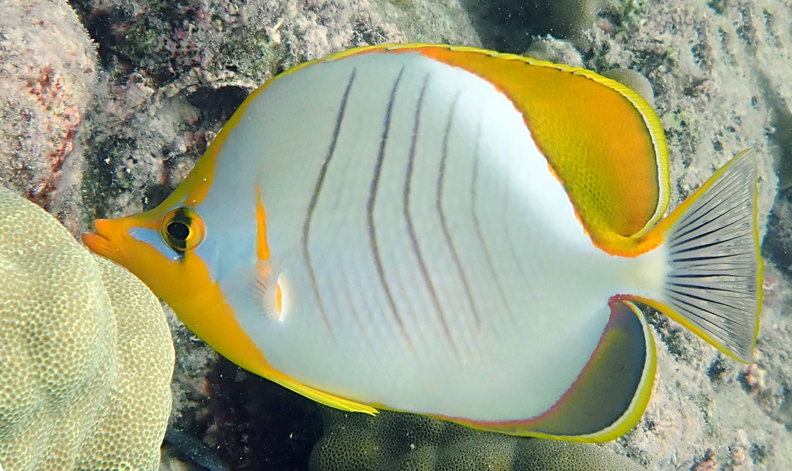

- What is the common name of Organism B? (1 point)
Butterflyfish

- All members of organism B have a deep, laterally compressed body. (1 point)
  - True
  - False

- All members of organism B are obligate corallivores. (1 point)
  - True
  - False

- Members of organism B typically have what feature near the back of their bodies to protect from predation? (3 points) Tie Breaker #2
False eye spot

- How do eggs produced by female members of organism B get released? (4 points)
Male swims behind and below female, uses his snout to nudge her abdomen (2 pts), then pair ascends into water column/rises up in body of water 10-15 ft and releases gametes (2 pts)

Use the following image for questions 40-44:
C:
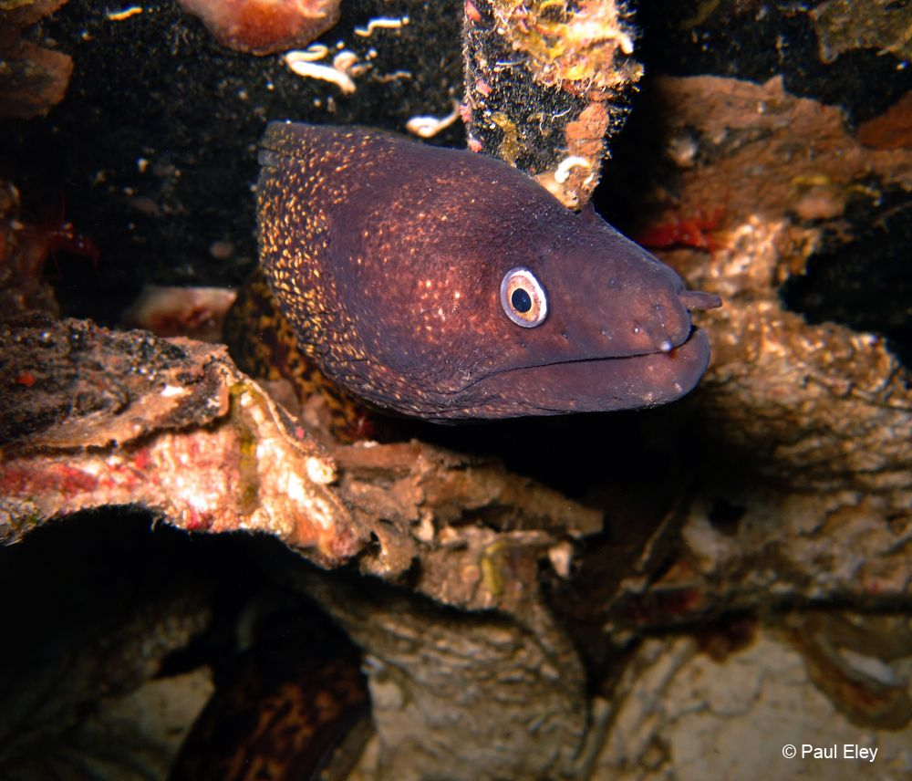

- What is the common name of Organism C? (1 point)
Moray eel

- Some members of organism C lack pelvic fins. (1 point)
  - True
  - False

- Which of the five senses is most relevant to helping members of organism C locate prey? (2 points)
Smell

- Members of organism C typically reproduce in which month? (2 points) Tie Breaker #6
  - January
  - April
  - July
  - September
  - November

- Up to what length can members of organism C grow, in feet? (2 points)
13

Use the following image for questions 45-49:
D:
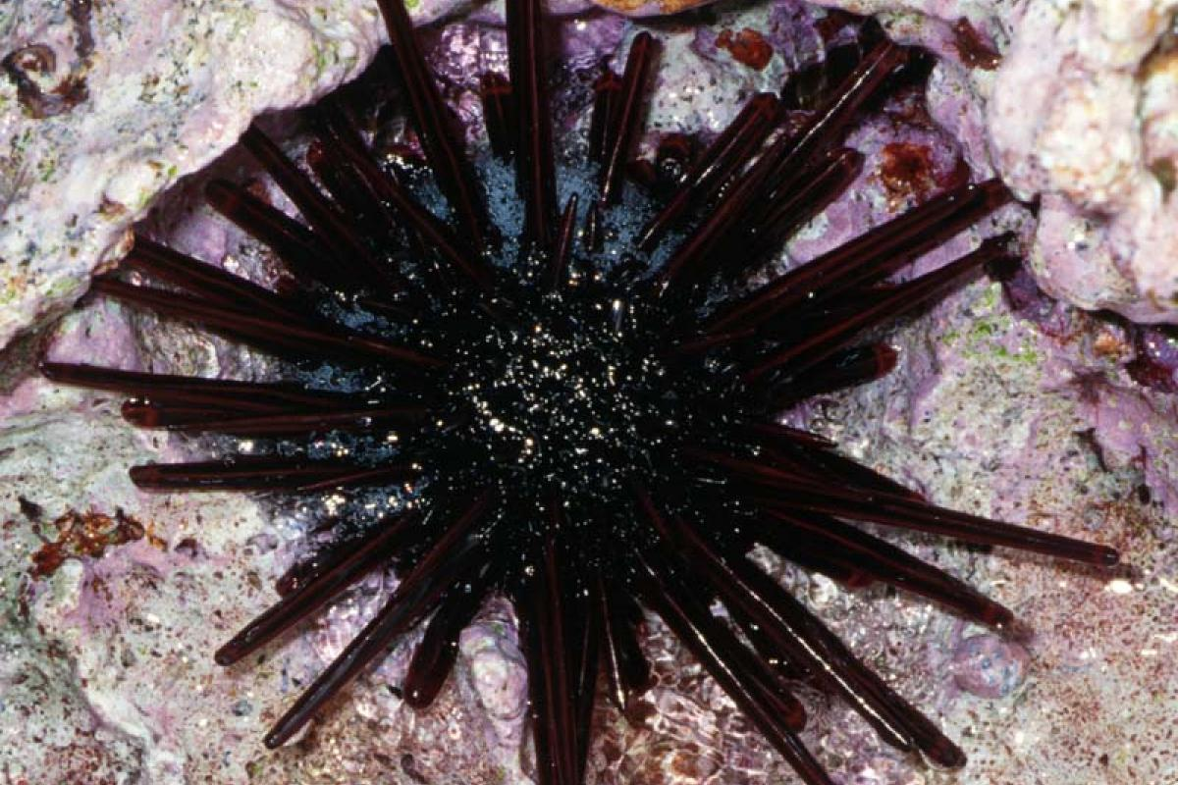

- What is the common name of organism D? (1 point)
Pencil urchin

- A high level of what causes "poor" water conditions for this organism? Under poor water conditions, what action(s) do members of organism D undertake? (4 points)
Nitrates (2 pts), shed spines (2 pts)

- Members of organism D are primarily omnivorous scavengers. (1 point)
  - True
  - False
- Members of organism D exhibit bilateral symmetry. (1 point)
  - True
  - False

- The spines of organism D are venomous. (1 point)
  - True
  - False

Use the following images for questions 50-54:
E: F:
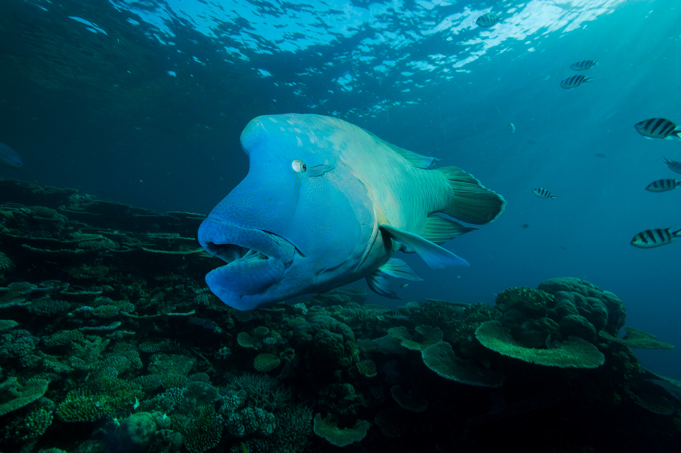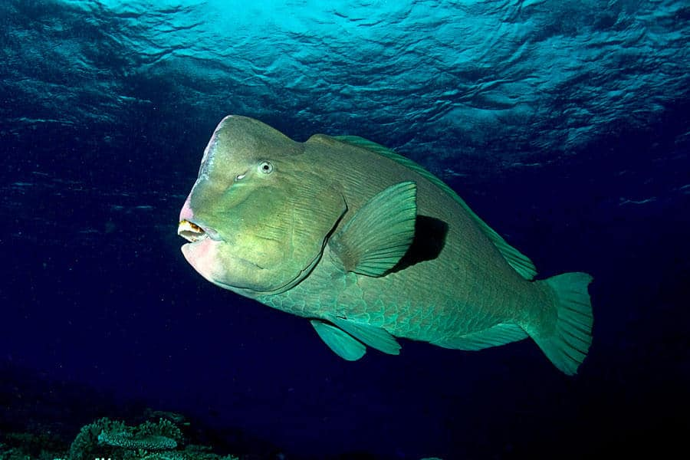

- What is the common name of organism E? (1 point)
Humphead Wrasse

- What is the common name of organism F? (1 point)
Bumphead Parrotfish

- Which organism, E or F, is more important in the sustainable development of a coral reef? Why? List the common name of this organism and what it excretes. (5 points)
F - bumphead parrotfish (1 point)
Eats dead coral (1 point) and cleans algae off of rocks (1 point), making room for new/more diverse corals to grow (1 point), excretes sand (1 point)

- What other species from the rules from this event do members of organism E consume? What does this "other species'' excessively consume? (4 points)
Crown of thorns starfish (2 points)
Corals/coral polyps (2 points)

- Which organism is more susceptible to overfishing? (1 point)
  - Organism E
  - Organism F

- Members of organism E grow up to weigh as much as _400_ lbs, whereas members of organism F grow up to weigh as much as _100_ lbs. Round each number to the nearest 100 lbs. (2 points)
Part III: Water Monitoring and Analysis
- Explain why you cannot determine the salinity of seawater by simply boiling the water and provide an example to illustrate this issue. (2 points)
Volatile substances are given off/vapors are released that will give an inaccurate measurement of the salt content. (1 point)
Acceptable examples include: bromide salts or iodide salts (are volatile at high temperatures), CO₂ gas, or HCl gas (1 point)

- Write the chemical formula for Aragonite. (1 point)
CaCO₃
(Aragonite is just calcium carbonate)

- In order for adequate coral reef formation, Ω should have a value between_________, which indicates that ___________. (1 point)
  - 3.0 and 3.5; the ocean water is supersaturated with aragonite
  - 3.5 and 4.0; the pH is low
  - 3.5 and 4.0; the ocean water is supersaturated with aragonite
  - 4.0 and 4.5; the pH is low
  - 4.0 and 4.5; there is low turbidity
Ω is the symbol for saturation, and for adequate coral reef formation it should be between 3.5 and 4. If Ω is greater than 4 then these conditions would be described as optimal. When Ω has a value greater than 1 it also indicates that the solution is supersaturated.

Use the table provided below of various Secchi disk measurements to answer questions 58 and 59.

 | Depth Secchi disk disappears (m) | Depth Secchi disk becomes visible again (m)
Location 1 | 12.50 | 9.40
Location 2 | 12.10 | 10.50
Location 3 | 11.70 | 10.30

- Which location will have the highest turbidity? Show your work. (2 points)
Location 1: (12.50 m + 9.40 m)/2 = 10.95 m
Location 2: (12.10 m + 10.50 m)/2 = 11.30 m
Location 3: (11.70 m + 10.30 m)/2 = 11.00 m

Location 1 has the lowest Secchi depth and therefore will have the highest turbidity.
(1 point for providing calculation and 1 point for the correct answer)

- Determine how deep photosynthesis will be able to occur in location 2. Provide your answer to the nearest hundredth and show your work. (2 points)
From question 58, we have the Secchi depth for location 2 is 11.30 m.
Photosynthesis will occur 2 - 3 times the Secchi depth, so 22.60 m - 33.90 m (1 point for correct answer)

- BOD tests were conducted on a water sample over 5 days at 20℃. 30 mL of the water sample was diluted with dilution water to form 400 mL of sample. The initial DO of the diluted sample is 7.5 mg/L, and after 5 days the DO of the diluted sample is 1.0 mg/L. The initial DO of the seeded dilution water is 9.9 mg/L, and after 5 days the DO of the seeded dilution water is 6.8 mg/L. Calculate the seeded BOD. Show your work. (4 points)
Seeded BOD equation: $BOD=\frac{(D_{1} - D_{2}) - (B_{1} - B_{2}) f}{P}$
D₁ = initial DO of diluted sample
D₂ = final DO of diluted sample after 5 days
B₁ = initial DO of seeded dilution water
B₂ = final DO of seeded dilution water after 5 days
f = (400 mL - 30 mL)/400 mL = 0.925 f is also equal to 1 - P
P = 15 mL/400 mL = 0.075
$BOD=\frac{(7.5 mg/L - 1.0 mg/L) - (9.9 mg/L - 6.8 mg/L) 0.925 }{0.075}$= 48.43 mg/L

- An excess of phosphate will cause a(n) _______ in plant and algae growth, leading to a(n) ________ in dissolved oxygen. (1 point)
  - decrease; decrease
  - decrease; increase
  - increase; decrease
  - increase; increase
  - A change in phosphate levels will not affect plant growth
  - A change in phosphate levels will not affect algae growth
Phosphate levels that are too high will lead to an increase in the growth of algae and plants, which will use more dissolved oxygen

- What is the average weight percentage of salt in seawater? (1 point)
3.5%

- Increasing the salinity of seawater by 1.00 kg/m³ will cause its density to increase by how much? Please provide your answer in lbs/ft³ and you are not required to show work.
Hint: 16.0185 kg/m³ = 1 lbs/ft³. (2 points)
Increasing the salinity of seawater by 1.00 kg/m³ will cause its density to increase by 0.70 kg/m³.
Converting between units: $(\frac{0.70 kg/m^{3}}{1})(\frac{1 lbs/{ft}^{3}}{16.0185 kg/m^{3}})$ = 0.04370 lbs/ft³ (accepting answers different up to ± 0.001 lbs/ft³, so answers between 0.042 lbs/ft³ and 0.044 lbs/ft³ would all be accepted)

Use the image below to answer question 64.
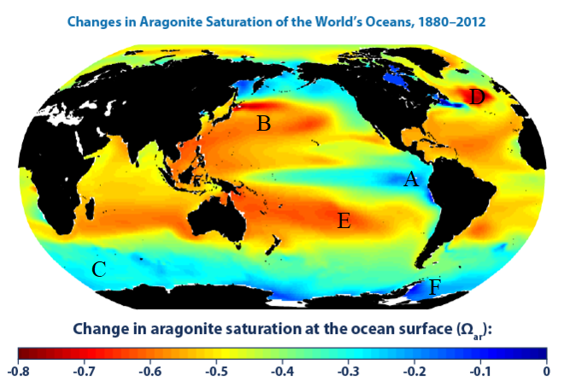

- In which three regions (A through F) labeled on the map will seawater be more acidic and explain why this conclusion can be made. (4 points)
B, D, and E (1 point each)
A negative change in aragonite indicates a decrease in saturation over time. As water pH decreases aragonite will be broken down to make other ions, decreasing its concentration. (1 point for explanation)

- An area of seawater originally was found to have a pH of 8.25. After 132 years the pH dropped to 8.1. How has the concentration of H⁺ ions changed? You are not required to show work. (2 points)
We can first find the original concentration of H⁺ ions in the seawater.
[H⁺] = 10^{-pH} = 10^{-8.25} = 5.623E-9 M
The concentration of H+ ions after 132 years is:
[H⁺] = 10^{-pH} = 10^{-8.10} = 7.943E-9 M

7.943E-9 M - 5.623E-9 M = 2.320E-9 M

- As CO₂ dissolves in seawater it reduces its concentration of __CO₃²⁻/carbonate ions__, causing the dissolution of organisms such as coral to occur. (1 point)
CO₂ dissolving in seawater reduces the concentration of CO₃²⁻ available, which creates an imbalance in the equation Ca²⁺ + CO₃²⁻ ⇌ CaCO₃.

- Below the seasonal thermocline in low latitude regions: (1 point)
- There is little temperature variation with increasing depth
- Temperature increases with increasing depth
- There is a permanent thermocline and temperature decreases with increasing depth
- a and c are correct
- There is no seasonal thermocline in low latitude regions
- There is a seasonal thermocline in low latitude regions, but none of the statements are correct

- You obtain 36 mg of dried residue from a sample of 175 mL. Calculate how many mg of total solids per liter are in the sample? Show your work and round your answer to the nearest whole number. (3 points)
175 mL = 0.175 L
36 mg/0.175L = 206 mg/L

- Describe the relationship between turbidity and water flow. Make sure to explain your reasoning. (3 points)
As water flow increases turbidity will increase as well, or low flow results in lower turbidity. (1 point for relationship)
As water flow increases the water has a greater velocity and volume, making it easier to stir up sediments. (2 points for explanation)

- Escherichia coli is a type of fecal coliform. (1 point)
  - True
  - False

- Bacteria can be ___100____ times more concentrated within the tissue of shellfish than in the surrounding water. (1 point)

- Most types of coliform bacteria are not harmful, and they can be used as indicator organisms to determine if other biological pathogens or fecal matter is present in a water system. (1 point)
  - True
  - False

- Which of the following can result from the presence of pathogens in water? (1 point)
  - Ear infections
  - Dysentery
  - Typhoid fever
  - Gastroenteritis
  - Hepatitis A
  - All of the above

- What is the chemical formula of orthophosphate? What process does this form of phosphorus play a key role in? (2 points) Tie Breaker #3
PO₄³⁻ (1 point)
Photosynthesis (1 point)

- Which of the following are correct statements about changing water temperatures? (Mark ALL correct answers) (2 points)
  - Organisms will become more susceptible to disease as water temperatures increase
  - The ability of water to hold dissolved oxygen will increase as water temperatures increase
  - Thermal pollution can lead to the overpopulation of aquatic plants
  - A change in water temperature can benefit certain species
  - Species can quickly die as a result of sudden temperature changes

- Which of the following are key elements in the manometric method of determining DOB? (Mark ALL correct answers) (2 points)
  - Pressure sensor
  - Seeding
  - Sealed container with a CO₂ absorbing substance
  - Dilution of sample
  - Oxygen consumption measurement

- Potentiometry is used to measure what data type? Briefly explain this process in a sentence or two. (3 points)
Measures pH (1 point)
The electronic amplifier detects the difference in electrical potential between the two electrodes (1 point) and converts the potential difference to pH units (1 point).

- Provide an example of suspended solids. (1 point)
Silt and clay particles, plankton, algae, fine organic debris, and other particulate matter are all acceptable answers

- While walking past a pond on a sunny day, you notice a very large amount of algae has grown in the water. What would you expect the minimum pH value of the lake to be? (1 point)
8
A high pH (greater than 8.0) can be an indicator of photosynthesis by large quantities of algae, therefore you can expect the minimum pH value to be around 8.

- What parameter would be used to determine the extent of respiration throughout the ocean? How would you calculate this parameter? (2 points) Tie Breaker #5
Apparent Oxygen Utilization (AOU) (1 point)
AOU = dissolved oxygen concentration if the water was in equilibrium with the atmosphere at the temperature and salinity of the water - measured dissolved oxygen concentration (2 points)

- A CTD instrument is capable of measuring what three data types? (3 points)
Temperature, pressure, and salinity (1 point each)

